Google Dorks / Google hacking
site:ine.com
only show the domain result related to it.

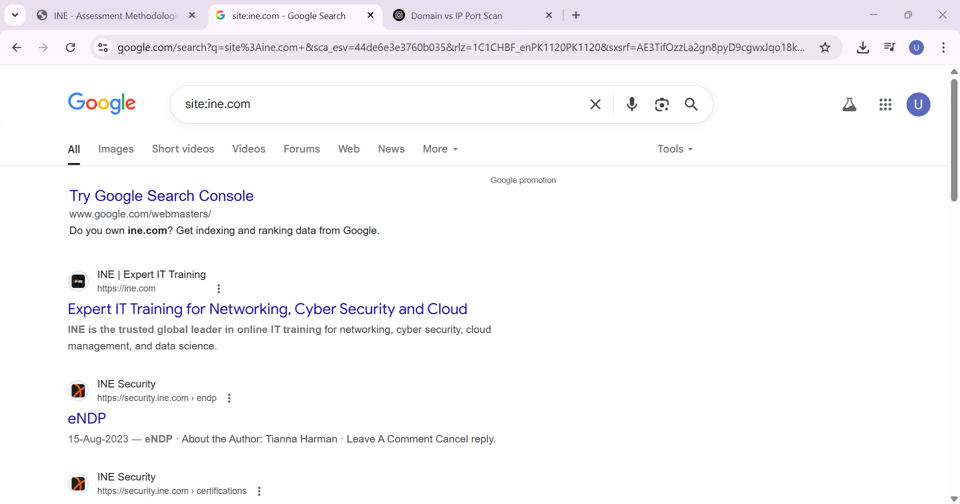

site:ine.com inurl:forum
check the same word in the url.
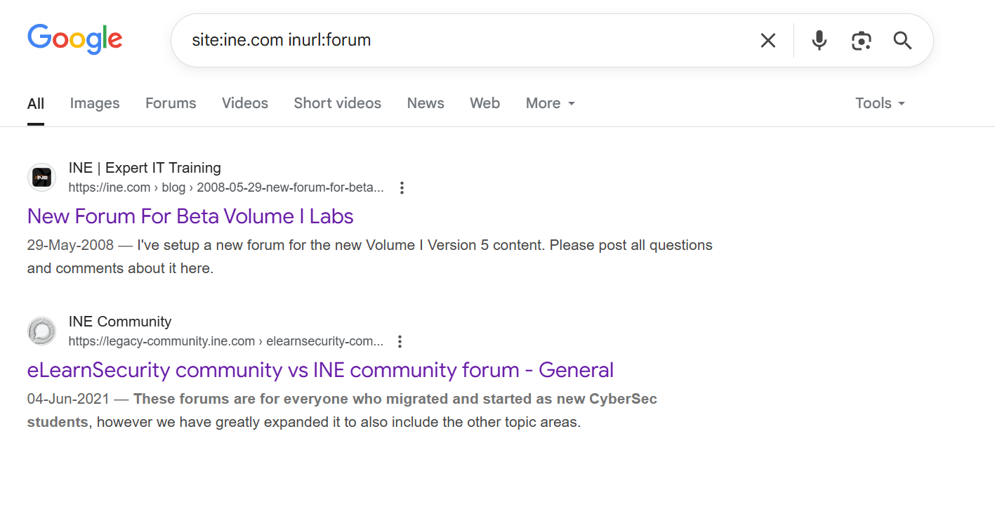
Site:*.ine.com
It will only give the subdomains of ine.com.
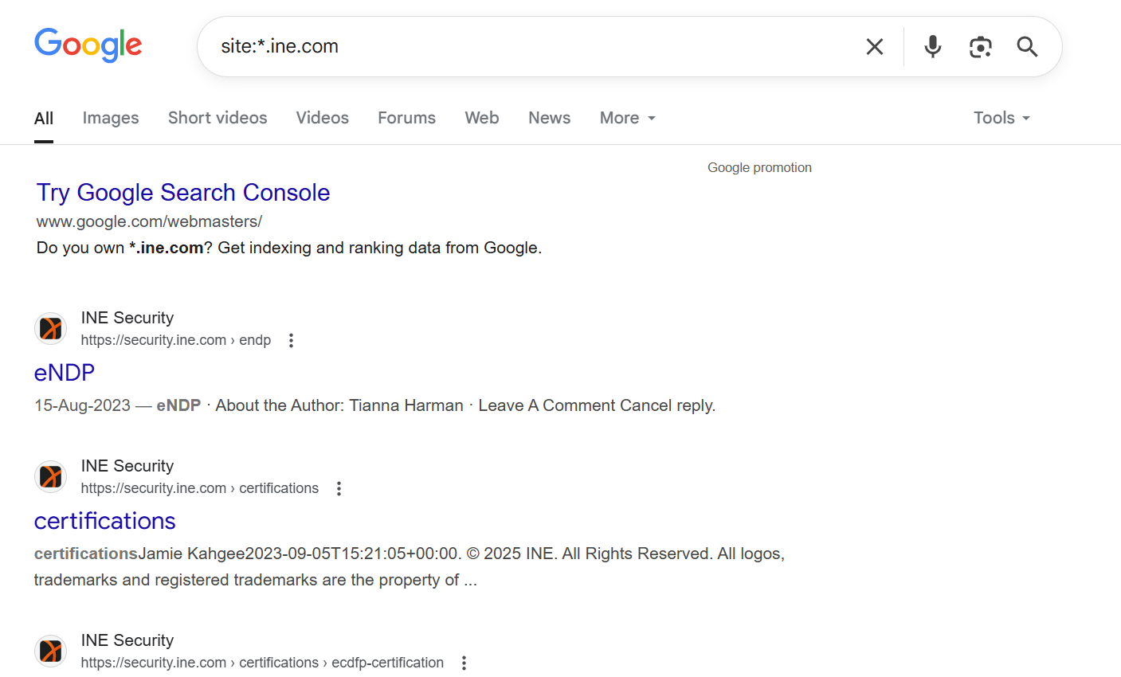

Note:
Sublist3r sue this to only connect with the subdomains of the site you want to check.

Site:*ine.com filetype:pdf

It check for the filetype pdf in the subdomain of the ine.com.

Index of:( directory listing )
This Google dork searches for web pages with the phrase "index of" in their <title> tag — which is commonly used by web servers to show directory listings when no index.html file is present.
Vulnerability in the webserver directory listing.
It can be used to see the content of the directories.

Condition | Will intitle:"index of" work?
index.html present On the server: | ❌ No — directory listing hidden
No index.html, listing allowed On the server: | ✅ Yes — shows auto-generated listing

Want to find older version of the website:
cache:ai-centre.pk

Show the most recent cached (saved) version of a page that Google has stored.

Waybackmachine:
The Wayback Machine is an online internet archive that captures and stores snapshots of websites over time.

inurl:auth_user_file.txt
inurl:passwd

https://www.exploit-db.com/google-hacking-database

this contain the dorking cooamds for the google that we can use to get the data.

Note:
Wp-config:
Contain the credential to the mysql database.’

